

BigShop Shopping Website

Project PArtner :

khushi sompura

Modi priya

Er-Diagram Shopping Website

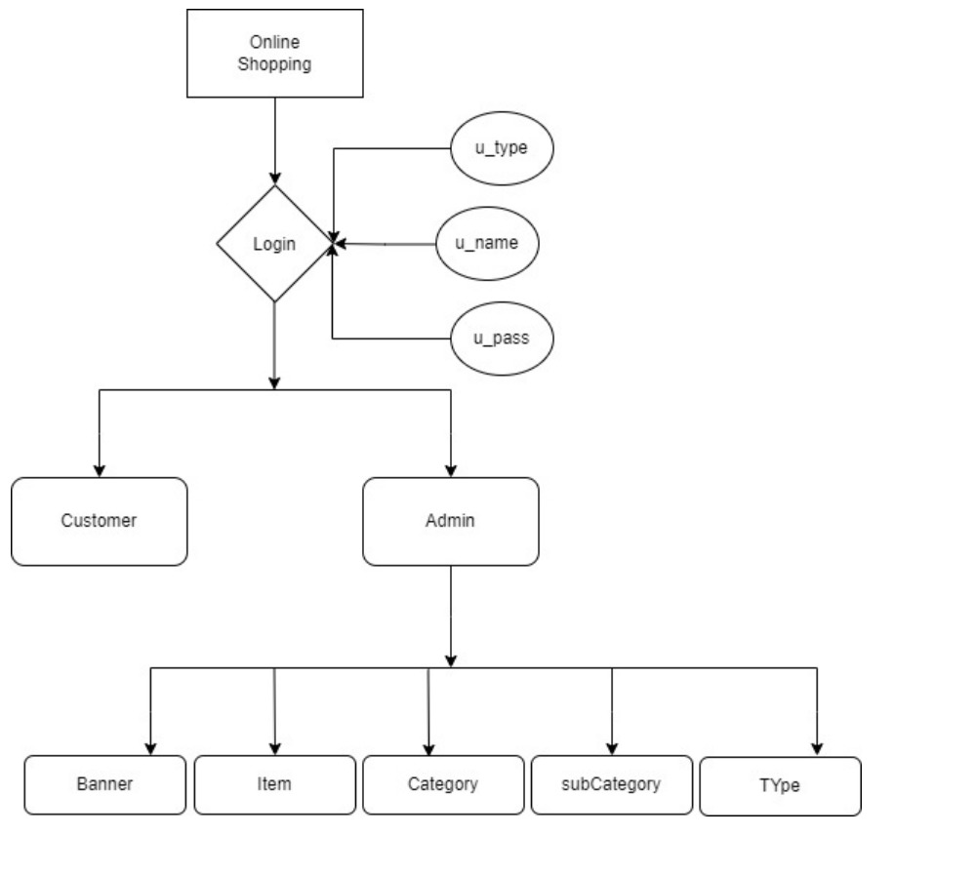

Usecase Diagram

Shopping Website

